Template for Accordion Learning Object

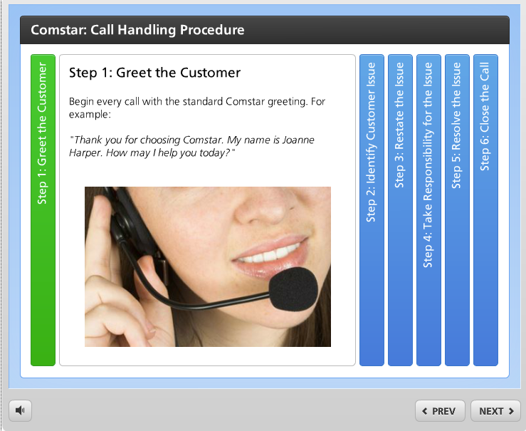
Link to sample

Reveal related items or steps in a process one at a time. Learners click each panel to uncover text and/or images.

Learning Object Requirements:

- Each step should be limited to a couple brief paragraphs for optimal viewing.
- Any images used must adhere to copyright and fair use policies
- Images (if used) must be high quality/clear so they do not appear blurry
- There can be 3-8 steps. Leave extra steps blank

Requestor name
(ID or Faculty Requesting Learning Object)
Requestor email
Bb Course Information
(ART 101 – 21879)
Location in Bb
(Describe where the learning object should be placed within your Bb course – e.g. Unit 1, right after the World Art Activity and before the World Art Writing Assignment)
Name of Learning Object
(e.g. Elements of Art)
Images uploaded to Dropbox?
* When all information is filled in, upload this template along with any images (if applicable) to the following dropbox link: http://onlinestudio.asu.edu/learning-object-form

* List the image file names used in this interactive
e.g. art.jpg, worldart.png
Step 1 Label  (column user clicks on) | Step 1 text (and image file name if applicable – art.jpg)  (Information that you are providing after user clicks step)
Step 2 Label | Step 2 text (and image file name if applicable – art.jpg)
Step 3 Label | Step 3 text (and image file name if applicable – art.jpg)
Step 4 Label | Step 4 text (and image file name if applicable – art.jpg)
Step 5 Label | Step 5 text (and image file name if applicable – art.jpg)
Step 6 Label | Step 6 text (and image file name if applicable – art.jpg)
Step 7 Label | Step 7 text (and image file name if applicable – art.jpg)
Step 8 Label | Step 8 text (and image file name if applicable – art.jpg)

Remember to save this document and upload to http://onlinestudio.asu.edu/learning-object-form

