Template for Folder Learning Object

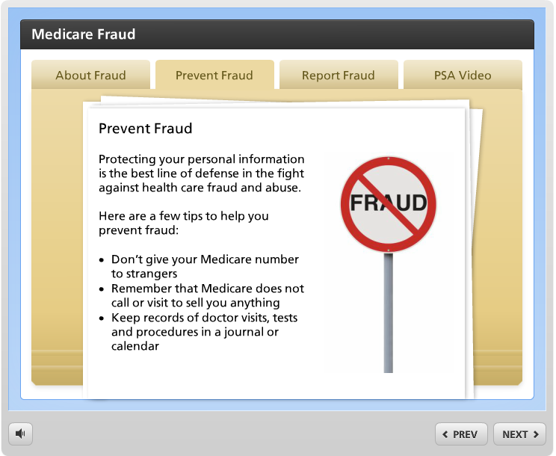
Link to sample

Let learners dig deeper into related content by clicking tabs on a folder.

Learning Object Requirements:

- Each tab should be limited to a four brief paragraphs for optimal viewing.
- Any images used must adhere to copyright and fair use policies
- Images (if used) must be high quality/clear so they do not appear blurry
- There can be 3-8 tabs on the folder. Leave extra tabs blank

Requestor name
(ID or Faculty Requesting Learning Object)
Requestor email
Bb Course Information
(ART 101 – 21879)
Location in Bb
(Describe where the learning object should be placed within your Bb course – e.g. Unit 1, right after the World Art Activity and before the World Art Writing Assignment)
Name of Learning Object
(e.g. Elements of Art)
Images uploaded to Dropbox?
* When all information is filled in, upload this template along with any images (if applicable) to the following dropbox link: onlinestudio.asu.edu/learning-object-form

* List the image file names used in this interactive
e.g. art.jpg, worldart.png
Tab 1 Label  (column user clicks on) | Tab 1 text (and image file name if applicable – art.jpg)  (Information that you are providing after user clicks step)
Tab 2 Label | Tab 2 text (and image file name if applicable – art.jpg)
Tab 3 Label | Tab 3 text (and image file name if applicable – art.jpg)
Tab 4 Label | Tab 4 text (and image file name if applicable – art.jpg)
Tab 5 Label | Tab 5 text (and image file name if applicable – art.jpg)
Tab 6 Label | Tab 6 text (and image file name if applicable – art.jpg)
Tab 7 Label | Tab 7 text (and image file name if applicable – art.jpg)
Tab 8 Label | Tab 8 text (and image file name if applicable – art.jpg)

Remember to save this document and upload it to onlinestudio.asu.edu/learning-object-form

