Template for Question Flashcards Learning Object

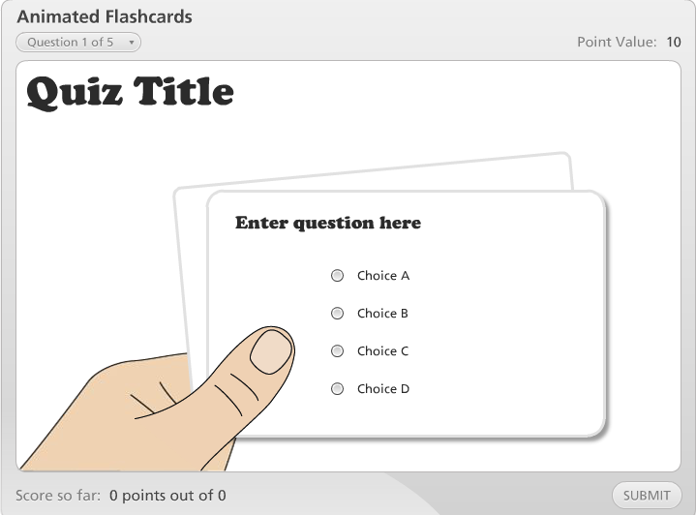
Link to sample

Illustrated hands holding a series of animated question and answer cards.

Learning Object Requirements:

- Questions may be multiple choice, multiple response, fill in the blank, word bank, and sequence drop-down
- If using images, they must be high quality/clear so they do not appear blurry (any images used must adhere to copyright and fair use policies)
- There may be up to 20 questions.
- Leave extra boxes blank

Requestor name
(ID or Faculty Requesting Learning Object)
Requestor email
Bb Course Information
(ART 101 – 21879)
Location in Bb
(Describe where the learning object should be placed within your Bb course – e.g. Unit 1, right after the World Art Activity and before the World Art Writing Assignment)
Name of Learning Object
(e.g. Elements of Art)
Images uploaded to Dropbox?
* When all information is filled in, upload this template along with any images (if applicable) to the following dropbox link: onlinestudio.asu.edu/learning-object-form

* List the image file names used for this interactive
e.g. Diagram.jpg, Chart.png
Introduction Text
(First screen that is shown – Include image title if you would like an image to appear on introduction screen as well)

1 Question Type  (Multiple choice, multiple response, fill in the blank, word bank, or sequence drop down) | 1 Question text  (include image file name if applicable) |  | 1 Answer text  (Be as explicit as possible and include a *star next to the correct answer(s).
2 Question Type  (Multiple choice, multiple response, fill in the blank, word bank, or sequence drop down) | 2 Question text |  | 2 Answer text  (Be as explicit as possible and include a *star next to the correct answer(s).
3 Question Type  (Multiple choice, multiple response, fill in the blank, word bank, or sequence drop down) | 3 Question text |  | 3 Answer text  (Be as explicit as possible and include a *star next to the correct answer(s).
4 Question Type  (Multiple choice, multiple response, fill in the blank, word bank, or sequence drop down) | 4 Question text |  | 4 Answer text  (Be as explicit as possible and include a *star next to the correct answer(s).
5 Question Type  (Multiple choice, multiple response, fill in the blank, word bank, or sequence drop down) | 5 Question text |  | 5 Answer text  (Be as explicit as possible and include a *star next to the correct answer(s).
6 Question Type  (Multiple choice, multiple response, fill in the blank, word bank, or sequence drop down) | 6 Question text |  | 6 Answer text  (Be as explicit as possible and include a *star next to the correct answer(s).
7 Question Type  (Multiple choice, multiple response, fill in the blank, word bank, or sequence drop down) | 7 Question text |  | 7 Answer text  (Be as explicit as possible and include a *star next to the correct answer(s).
8 Question Type  (Multiple choice, multiple response, fill in the blank, word bank, or sequence drop down) | 8 Question text |  | 8 Answer text  (Be as explicit as possible and include a *star next to the correct answer(s).
9 Question Type  (Multiple choice, multiple response, fill in the blank, word bank, or sequence drop down) | 9 Question text |  | 9 Answer text  (Be as explicit as possible and include a *star next to the correct answer(s).
10 Question Type  (Multiple choice, multiple response, fill in the blank, word bank, or sequence drop down) | 10 Question text |  | 10 Answer text  (Be as explicit as possible and include a *star next to the correct answer(s).
11 Question Type  (Multiple choice, multiple response, fill in the blank, word bank, or sequence drop down) | 11 Question text |  | 11 Answer text  (Be as explicit as possible and include a *star next to the correct answer(s).
12 Question Type  (Multiple choice, multiple response, fill in the blank, word bank, or sequence drop down) | 12 Question text |  | 12 Answer text  (Be as explicit as possible and include a *star next to the correct answer(s).
13 Question Type  (Multiple choice, multiple response, fill in the blank, word bank, or sequence drop down) | 13 Question text |  | 13 Answer text  (Be as explicit as possible and include a *star next to the correct answer(s).
14 Question Type  (Multiple choice, multiple response, fill in the blank, word bank, or sequence drop down) | 14 Question text |  | 14 Answer text  (Be as explicit as possible and include a *star next to the correct answer(s).
15 Question Type  (Multiple choice, multiple response, fill in the blank, word bank, or sequence drop down) | 15 Question text |  | 15 Answer text  (Be as explicit as possible and include a *star next to the correct answer(s).
16 Question Type  (Multiple choice, multiple response, fill in the blank, word bank, or sequence drop down) | 16 Question text |  | 16 Answer text  (Be as explicit as possible and include a *star next to the correct answer(s).
17 Question Type  (Multiple choice, multiple response, fill in the blank, word bank, or sequence drop down) | 17 Question text |  | 17 Answer text  (Be as explicit as possible and include a *star next to the correct answer(s).
18 Question Type  (Multiple choice, multiple response, fill in the blank, word bank, or sequence drop down) | 18 Question text |  | 18 Answer text  (Be as explicit as possible and include a *star next to the correct answer(s).
19 Question Type  (Multiple choice, multiple response, fill in the blank, word bank, or sequence drop down) | 19 Question text |  | 19 Answer text  (Be as explicit as possible and include a *star next to the correct answer(s).
20 Question Type  (Multiple choice, multiple response, fill in the blank, word bank, or sequence drop down) | 20 Question text |  | 20 Answer text  (Be as explicit as possible and include a *star next to the correct answer(s).

Remember to save this document and upload it to onlinestudio.asu.edu/learning-object-form

